日期 | 機台 | RECIPE | PTC OOS | TEST RUN PTC | 機台處理說明 | 產品PE or KLA check | MW狀態 | 備註
03/20 | N1 | N08 | PTC = 81 | PTC = 30/31/2  PTC = 0/0/2 | Run N08 PTC=81 OOS  分佈在三點鐘方向一坨  check transfer and clean環境ok  replace boat dummy ok | 25102510  AOI Def%: 0.03~0.13% | 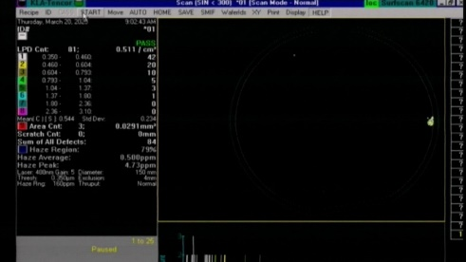 | 已申請刪除

